**Salt for industrial use**

**1:- Rock crystal salt for industrial use** (one time washed rock crystal salt)

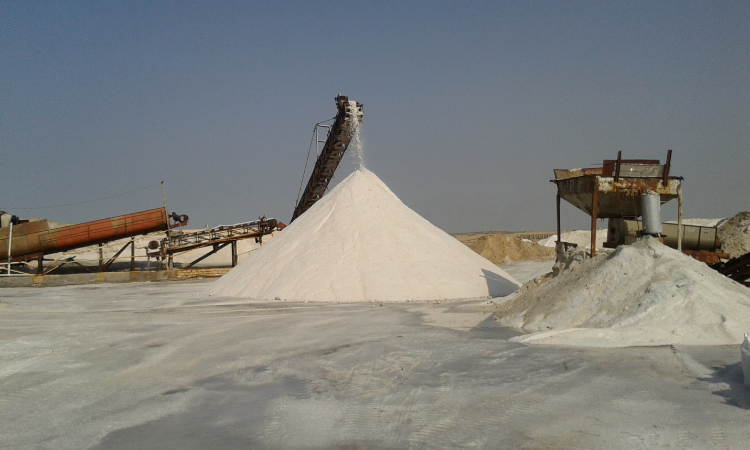

Salt It is a key component in the production of different industries, as almost all industries in the world use sodium chloride salt, either as a main material or an additive.  Chemical industries represent the largest consumers  of salt, which is used in the production of prime chemicals , chlorine that is used  in water treatment facilities,Caustic Soda used as a dyes in textile and detergents,Soda Ash is used in glass , soap  and leather tanning industry , Manufacture of paper - plastics - ceramics , fertilizer etc

Purity over 99.5% and moisture less than 0.5 % Insoluble 0.3 %

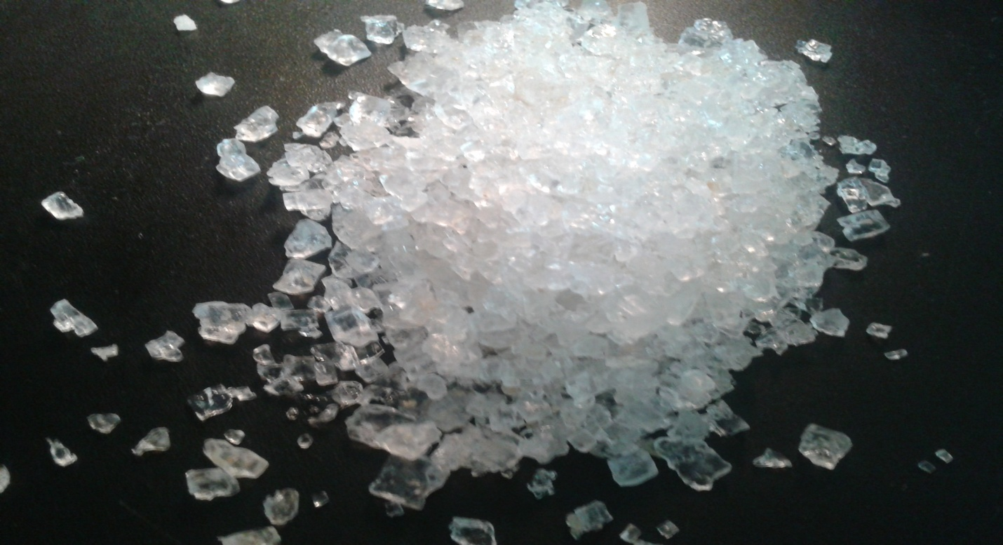

**2:-we offer one time or two times sea crystal salt for industrial use too .**

Nacl min for sea crystal salt 98.5% moisture from 1-3%



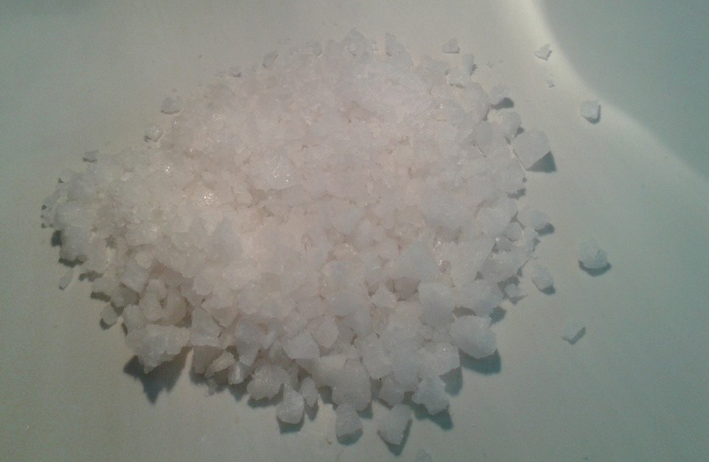

**condition of sales**

Minimum Order Quantity: 3000 metric tons

Shipment: in bulk

Our loading vessel rate best rate for loading vessel in Egypt without any delay

Origin: Egypt

Delivery terms: EXW , FOB , CIF OR EVEN DDP to the warehouse of our client , incomers 2010

Packing options bags 50k.g , or bags 25 k.g or jumbo bags 1 ton or 1.5 ton in bags min order 200 ton

Shipping documents:

* Commercial invoice;;
* Ocean/CP bill of lading, railway bill;
* Certificate of origin;
* Certificate of quality issued by independent surveyor; SGS

Payment options:

* Advance payment;

Irrevocable Letter of Credit at sight issued by a Top World Bank and available with Seller's bank only if order is 3000 MT min

3:- **tablet salt for water softener**

Details : pressed salt in oval rectangular shape of 2.5*2.0*1.0 cm ,used in water treatment units to activate chemical resins . 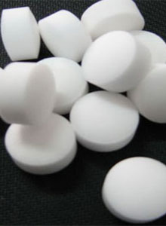

Packing : pollyethelin packge inside pollyproblin one of 25 k.g

Specifications: Sodium chloride NACL ( dry base) :99.0-99.5%

Insoluble matter: 0.10-0.15 %

Soluble matter: 0.40-0.85 %

Bicarbonate: 0.024-0.049 %

Sulphate: 0.30-0.55 %

Calcium: 0.040-0.13 %

Magnesium: 0.034-0.12%